User Manual

SPD1000X Programmable Linear DC Power Supply

UM0501X-E02A

2018 SIGLENT TECHNOLOGIES CO., LTD

Copyright and Declaration

Copyright
SIGLENT TECHNOLOGIES CO.，LTD. All Right Reserved.

Trademark Information
SIGLENT is a registered trademark of SIGLENT TECHNOLOGIES.

Declaration
- SIGLENT products are protected by patent law in and outside of the People’s Republic of China
.
- SIGLENT reserved the right to modify or change the specifications and price of the product

- Information in this publication replace all previous corresponding material

- Any copying, extracting or translation of the content of this manual is not allowed without permission from SIGLENT.

General Safety Summary
Please review the following safety precautions carefully to avoid personal injury or damage to this product or any product connected to it. To prevent potential danger, please use the instrument as specified.

Use the proper power cord
Only the power cord designed for the instrument and authorized by the local country should be used.

Power supply
AC Input Voltages: 100/120/220/230 V ± 10%，50/60 Hz

Use the proper fuse
The fuse type: 100/120 V: T6.3A/250V
220/230 V : T3.15A/250V

Make sure to use the correct type of fuse before turning on the instrument.
Find the cause of the fuse failure before replacing the fuse and connecting the power cord.

Ground the instrument
The instrument is grounded through the protective Earth conductor of the power cord. To avoid electric shock, the grounding conductor must be connected to the Earth ground. Make sure that the instrument is properly grounded before any activating any inputs or outputs.

Examine all the terminal ratings
To avoid fire or electric shock, please examine all ratings and symbols on the instrument. Read this guide carefully to learn more details about the ratings before connection.

Keep proper ventilation
Inadequate ventilation may cause an increase of temperature within the instrument, which can lead to instrument damage. Please maintain proper ventilation and check the fan and air-vents regularly when using the instrument.

Operating conditions
Location: indoor, no excessive bright lighting, minimal air pollution
Relative humidity: < 80%
Altitude: < 2000 m
Temperature: 0 ℃ to 40 ℃

Electrostatic Prevention
Operate in an electrostatic discharge protected area environment to avoid damages induced by static discharges. Always ground both the internal and external conductors of the cable to remove static before connecting.

Do not operate in an explosive atmosphere
To avoid personal injury or damage to the instrument, please do not operate in an explosive atmosphere.

Keep surface of the product clean and dry
Avoid dust and moisture in the air as they can influence the performance of the instrument. Please keep surface of the product clean and dry.

Safety Terms and Symbols
Terms may appear on the product:

DANGER: Indicates direct injury or hazard that may occur.

WARNING: Indicates potential injury or hazard that may occur.

CAUTION: Indicates potential damage to the instrument or other property that may occur.

Symbols may appear on the product:


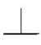
Hazardous
Hazardous
Power
Protective
Earth Terminal
Warning
Earth
Ground
Power
Switch

SPD1000X Brief Introduction
The Siglent SPD1000X Programmable DC Power Supply has a 2.8 inch TFT-LCD screen, programmable output, and real time graphical trending display. The SPD1168X has maximum output values of 16 V/8 A. The SPD1305X has maximum output values of 30 V/5 A. Both models provide remote sensing as well as output short circuit and overload protection. The SPD1000X is suitable for a variety of applications in research and development, production and repair.
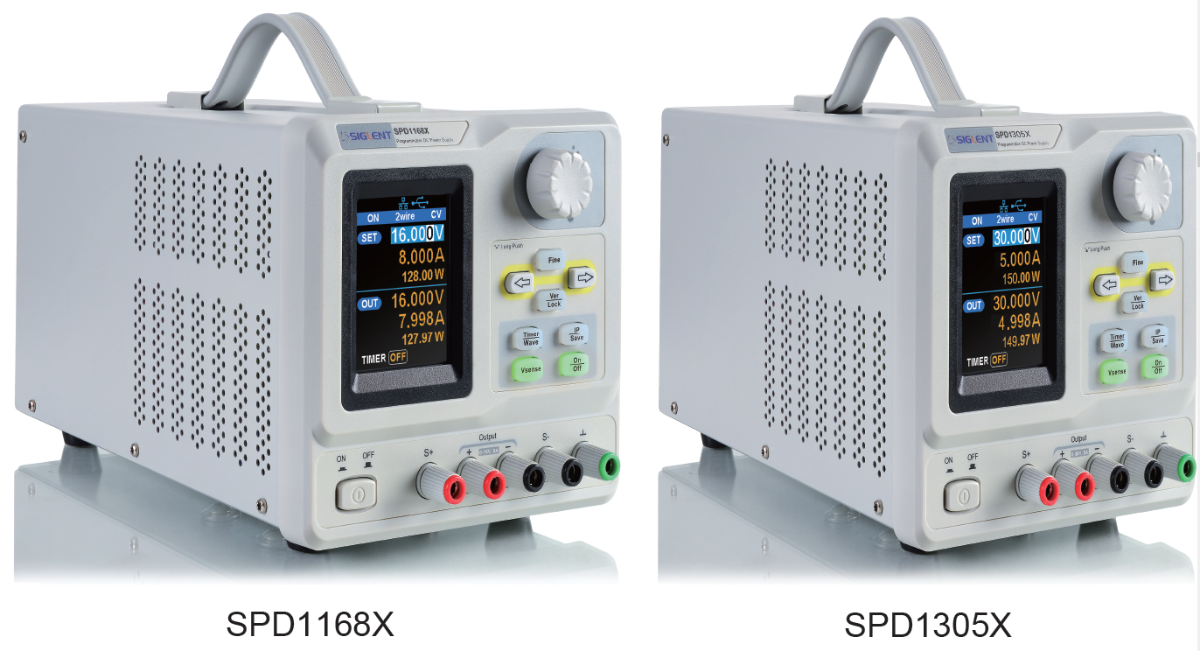

Main features:

- Single high-precision programmable output:
SPD1168X: 16 V/8 A, total power available is 128 W
SPD1305X: 30 V/5 A, total power available is 150 W

- Compact and easy to use, ideal for bench power supply

- Stable, reliable and low noise: ≤ 350 uVrms/3 mVpp

- Fast Transient Response Time: < 50 μs

- Maximum resolution of 1 mV, 1 mA with 5-digit voltage and 4-digit current display.

- Timer function sequences preset output values

- High resolution 2.8 inch TFT LCD (240*320 pixels)

- Two output modes: two-wire output and remote sense compensation function (maximum compensation up to 1 V)

- Four input/line voltage selection choices including 100 V, 110 V, 220 V and 230 V to satisfy different requirements

- Intelligent temperature-controlled fan, effectively reduces noise

- Bright, clear graphical interface, with waveform display

- Five internal system parameter save / recall locations, support for data storage space expansion

- Comes with EasyPower PC software. Real-time control via USB, LAN. Supports SCPI command set and LabView driver package to meet the remote control and communication requirements

Content
Copyright and Declaration I
General Safety Summary II
Safety Terms and Symbols IV
SPD1000X Brief Introduction V
Chapter 1 Start Guide 1
1.1 General Inspection 2
1.2 The Front Panel 3
1.3 The Rear Panel 6
1.4 Connect Power 8
1.5 User Interface 10
1.6 Output Inspection 12
1.7 Fuse Replacement 13
Chapter 2 Control panel operation 14
2.1 Output summary 15
2.2 2-wire mode 17
2.3 Remote Sense mode 19
2.4 Configuration of LAN interface 21
2.5 Save and recall 23
2.6 Timer 27
2.7 Waveform display 31
2.8 Version information 32
2.9 Lock key 33
2.10 Upgrade firmware 34
Chapter 3 Remote control 37
3.1 Control method 37
3.2 Grammar conventions 38
3.3 Command Summary 39
3.4 Command description 41
3.5 Programming examples 49
Chapter 4 Common troubleshooting 61
Chapter 5 Service and Support 63
5.1 Maintenance summary 63
5.2 Contact SIGLENT 63

Chapter 1 Start Guide
In this chapter, we introduce the front panel and display interface of the SPD1000X, and also tips for how to check and operate the power supply the first time.

The main content of Chapter 1 includes:

- General Inspection
- The front panel
- The rear panel
- Connecting power
- User interface
- Output Inspection
- Fuse Replacement

General Inspection
Please check the instrument according to the following steps:

- Inspect the shipping container
Keep the shipping container and cushioning material until the contents of the shipment have been completely checked and the instrument has passed both electrical and mechanical tests. The consigner or carrier is responsible for damages to the instrument resulting from shipment. SIGLENT will not provide free maintenance or replacement for shipping damages.

- Inspect the instrument

If there is damage, defects, or failures in electrical and mechanical tests of the product, please contact your nearest SIGLENT sales representative.

- Check the accessories

Please check the accessories according to the packing list. If the
accessories are incomplete or damaged, please contact your
SIGLENT sales representative.

The Front Panel

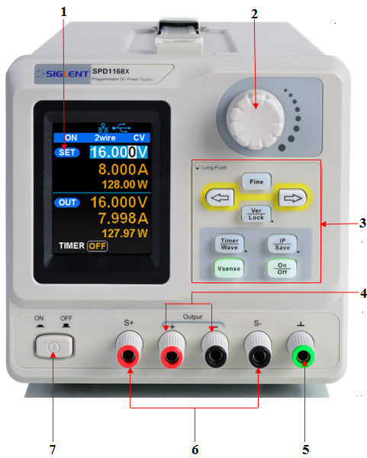

- LCD Display
2.8 inch TFT-LCD is used to display system parameter settings, system output state, menu options, prompt messages, etc.

- Knob
When setting parameters, rotate the knob to increase or decrease the value of the digit at the cursor. In the Store Page the knob can be used to quickly move to the desired file.

- Function button and power key
 When setting parameters, press the Fine button to move the cursor to select the position of digit to be modified.

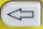 The left and right direction buttons move the cursor to select the parameter to be modified. Press the left button to move the cursor selection left / upward and press the right button to move the cursor selection right / downward.

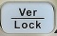 Press the button briefly to view the system information screen . Press the button for approximately 1 second or longer to activate the lock function.

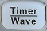 Press the button briefly to enter the timer interface. Press the left arrow button to move the cursor left / upward between fields/press the right arrow button to move the cursor right / downward between fields. Press the On/Off button for approximately 1 second or longer to turn on/off the timer.
Press the Timer / Wave button for approximately 1 second or longer period to enter the waveform display mode.

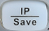 Press the button briefly to configure the network connection information. Then press the left / right buttons to step through the different IP Page addresses and fields. Choose the DHCP field, then press the On/Off button to turn off the IP Setting menu.
Press the IP/Save button for 1 second or longer to enter the storage function system. Press the Fine button to choose the file number location to access，press the Fine button for 1 second or longer to confirm the choice.

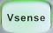 Press the button to enable/disable the remote sense function.

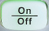 Press the button to enable/disable the channel output.

- Output Terminal
Physical output connections to the external circuit.

- Ground Terminal
This terminal is connected to the instrument chassis and ground wire, and is at ground potential.

- Sense terminal
Used to sense the actual voltage supplied at the load. This allows the source to compensate for any voltage drop caused by the leads between the power supply and the load and increases the accuracy of the voltage delivered to the load. Especially effective when using higher currents and/or longer leads.

- Power key
Turns the instrument on or off.

1.3 The Rear Panel

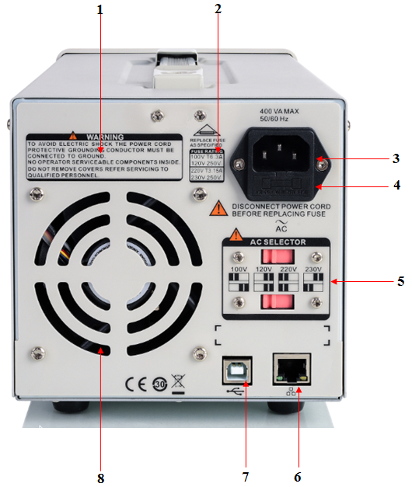

- Warning message
Warning message regarding proper grounding and instrument maintenance.

- AC input voltage description
The frequency, voltage and the specified fuse should correspond to the AC input mains.

- AC power socket
The socket for AC input power.

- Fuse
The specified fuse must be rated for the input voltage (Please refer to the “ AC input voltage description “)

- AC line power selection switch
AC Input Voltages: 100/120/220/230 V

- LAN interface
RJ45 jack for connection to any user-supplied LAN.

- USB device
USB-B connector for connection to a user-supplied USB controller.

- Fan

1.4 Connect Power
The power supply supports a variety of AC line power input values. For each line voltage, the rear panel voltage selector settings are different, as shown in table 1 below.

Table 1: AC input line power specifications
AC power input | Voltage selector configure
100 VAC ± 10%， 50 ~ 60 Hz | 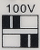
120 VAC ± 10%， 50 ~ 60 Hz | 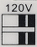
220 VAC ± 10%， 50 ~ 60 Hz | 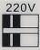
230 VAC ± 10%， 50 ~ 60 Hz | 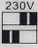

Please connect the external AC power carefully using the steps below:

- Check the input power
Make certain that the AC line power to be connected to the instrument meets the requirements outlined in Table 1.

- Check the voltage selector on the rear panel
Make certain that the voltage selector setting on the rear panel of the instrument matches the actual input voltage.

- Check the fuse
When the instrument leaves the factory, the specified fuse is installed. Please check whether the fuse matches the actual input voltage according to the "Input Power Requirements" on the rear panel of the instrument.

- Connect the power
Connect the instrument to AC power supply using the power cord provided with the accessories. Then press the button to turn on the power.

WARNING
Before switching the input power supply voltage, please disconnect the power supply before setting the voltage selector to the appropriate setting.

WARNING
To avoid electric shock, make certain that the instrument is correctly grounded.

1.5 User Interface
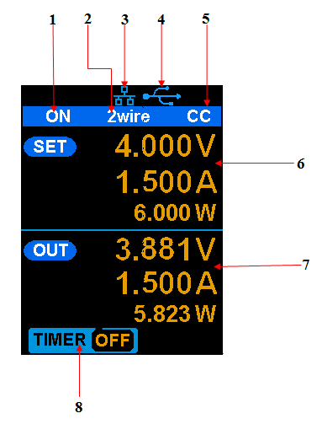

- Channel output state
On / Off
- Remote sense mode
2 wire：two wire mode，4 wire：four wire（remote sense）mode.
- LAN connection icon
When the instrument is connected to a network through the LAN port this flag is displayed.
- USB connection icon
When the instrument is connected to a computer via the USB DEVEICE interface this icon is displayed.
- Output mode
CV：Constant Voltage，CC：Constant Current.
- Output programmed values
Voltage，current，power settings
- Measured output values
Voltage，current，power actual output
- Timer state
On / Off

Output Inspection

- Check the output voltage

- Turn on the power and make certain the channel current setting is not zero when the instrument has no-load.
- Press on/off button, the supply should be working in constant voltage (CV) mode. You can check the voltage range of SPD1168X by adjusting the voltage setpoint from the minimum (0 V) to the maximum value (16 V) and the voltage range of SPD1305X by adjusting the voltage setpoint from the minimum (0 V) to the maximum value (30 V).

- Check the output current

- Turn on the power and make certain the voltage setting is not zero.
- Connect the output terminals (short) with an insulated wire that can
handle 10 A or more (18 AWG single core, for example).
- Activate the output by pressing the on/off button. The low impedance (shorted) output will cause the instrument to enter current control (CC) mode. You can check the current range of the SPD1168X by adjusting the current setpoint from the minimum (0 A) to the maximum value (8 A) and the current range of the SPD1305X by adjusting the current setpoint from the minimum (0 A) to the maximum value (5 A).

Fuse Replacement

The specifications of the fuse are relative to the actual input line voltage, shown in the table below. You also can refer to the rear panel “input power requirement”.
Input voltage | Fuse specification
100/120 VAC | T6.3A
220/230 VAC | T3.15A

To replace the fuse,please follow the steps below:
- Turn off the instrument and remove the power cord.
- Insert a small straight screwdriver into the slot at the power socket and gently pry out the fuse seat.
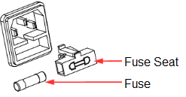
- Adjust the power voltage selector manually to select the correct voltage scale.
- Take out the fuse and replace it with the specified fuse (for the corresponding relationship between the AC input voltage and fuse specification, refer to the “input power requirement” at the rear panel).
- Re-insert the fuse holder into the power socket (please pay attention to the directions).

WARNING
To avoid personal injuries, unplug the power supply before replacing the fuse. To avoid electric shock or fire, select the proper power supply specification and replace only with the proper fuse.

Chapter 2 Control panel operation
In this chapter, the functions and operation of the SPD1000X control panel will be introduced in detail.
Brief introduction:
- Output summary
- Setting the output voltage and current of the power supply
- Remote terminal
- LAN configuration
- Save/recall
- Timer
- Waveform display
- Version information
- Lock
- Update

Output summary
- The SPD1000X provides a floating output. The output rating of the SPD1168X is 0-16 V / 0-8 A，while the output rating of SPD1305X is 0-30 V / 0-5 A;
- Two modes of output: constant voltage (CV) and constant current (CC);
- Two types of operation: two wire mode and remote sense mode.

Constant voltage output/constant current output:
In the constant current mode, the output current is a set value which can be controlled by the front panel. The user interface displays the output mode is ‘CC’ and the current is still in a set value. At this time, the voltage is lower than the set value. When the output current is less than the set value, the constant current mode will switch to constant voltage mode automatically.
In the constant voltage mode, the output current is less than the set value, which can be controlled by the front panel. The user interface displays the output mode is ‘CV’ and the voltage remains at the set value. When output current reaches the set value, the system switches to the constant current mode.

2-wire mode/remote sense mode:
When the SPD1000X is set to the 2-wire mode, the display prompt displays the working mode as “2-wire.” When the output is on, the instrument will detect and display the output terminal’s actual output mode automatically.

In the remote sense mode, the prompt displays the working mode as “remote sense.” When the output is on and the remote sense terminal connect to the load, the instrument will detect and display the actual output.

2-wire mode
The operation of the output power configuration follows:

Operation method:
- Connect the output terminals
As shown in the figure below, connect the load to the output terminals.

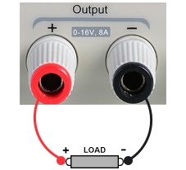

CAUTION
To avoid damages to the instrument, please pay attention to the positive and negative terminal polarities when connecting.

- Configure the output of voltage and current

- Selecting the parameters to change by moving the left / right arrow keys.
- Press Fine button to select the data’s position, then rotate the knob to change the parameter.

- Enable the output
Make certain the mode is 2-wire (the Vsense key is off and the display shows 2-wire). Press the On/Off button, the button light will light up, the channel output is enabled and the display shows the power supply status is "On".

Note: Built-in overvoltage protection; When the actual output voltage of the SPD1168X is greater than 22 ± 2 V or the actual output voltage of the SPD1305X is greater than 36 ± 2 V, the output will automatically short-circuit, and limit the voltage output. If this occurs, please re-engage the output enable switch to resume normal output.

Remote Sense mode
When the power supply is outputting a large current, a voltage drop can occur as a result of resistance in the output cable. To ensure an accurate output voltage, the SPD1000X provides a 4-wire (remote sense) mode of operation. In this mode, the voltage at the load terminal is detected instead of the voltage at the power supply output. This allows the instrument to automatically compensate for the voltage drop caused by the load leads, ensuring that the user-specified voltage output matches the voltage delivered to the load. Front panel Sense connections are as shown below.

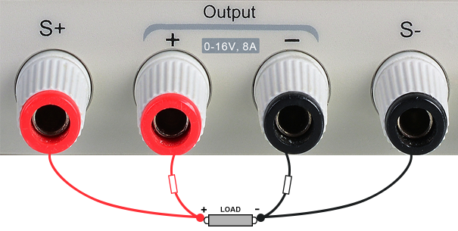

Operation method:

- Connect the output terminals and sense terminals
As shown above, connect the front panel output terminal and Sense terminal to both ends of the load. When connecting, please pay attention to polarity.
- Configure the voltage and current of output
- Select the parameters to change by moving the direction of cursor
- Press Fine button to select the cursor’s position, then rotate the knob to adjust the parameter.
- Open the 4-wire mode
Press Vsense button, the button will light up. The power supply screen will show ‘4 wire’ on the display.
- Enable the output
Press the on/off button, the button light is lit and the power supply display shows “on”.

Note: In 4-wire mode, the maximum compensation voltage of the power supply is 1 V. When the voltage difference between the output terminal and the Sense terminal is more than 1 V, the instrument will turn off automatically.

Configuration of LAN interface
The SPD1000X supports USB Device and LAN interfaces. You can remotely control the SPD1000X through these interfaces. When using the LAN interface, first set the interface parameters.

Operation methods:
- Use the network cable to connect the LAN port on the rear panel with the network where the computer or computers are located;
- Press IP/Save briefly to enter the network setting interface.
- After setting the IP value, press the multi-function knob or press the Fine button for 1 second or longer to make the setting effective, then press the left / right arrow buttons repeatedly to move the cursor to the DHCP line. Turn the knob to set DHCP to ON or OFF, then press the multi-function knob or press the On/Off button briefly to turn on/off the DHCP.
- ON: The power will automatically set the IP address, subnet mask and gateway automatically loaded according to the current access network.
- OFF: The user can set the IP address, subnet mask and gateway.
- Press the left/right arrow button to change the position of cursor.
- Rotate the knob or press the left and right arrow buttons for 1 second or longer to change the data.
- Press Fine button to change the highlighted digit.
- Press the knob or press the Fine button for a longer period to save the setting (all settings will take effect only if the knob is pressed or the Fine button is pressed for 1 second or longer.)
- Press IP/Save again to exit the network setting interface and return to the main screen.

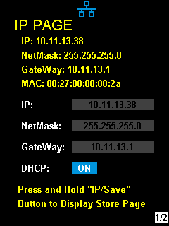

Save and recall
The SPD1000X allows the user to save the current instrument status (including operating modes, voltage/current settings, timer parameters, etc.) to the internal memory and recall saved files when required.

- Save
Operation steps:
- Set the parameter settings to be saved;
- Press IP/Save for 1 second or longer to enter to the Store Page screen.
- Press the direction button to move the cursor to “FILE CHOICE”;
- Rotate the knob or press the Fine button briefly to select the storage location (FILE 1~FILE 5);
- Press the arrow buttons to move the cursor to "OPER CHOICE"
- Turn the multi-function knob to select "STORE" and press the knob or press the Fine button for 1 second or longer to select "OK" to save the current settings. After saving, the corresponding file location will turn yellow.

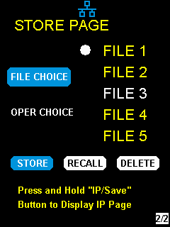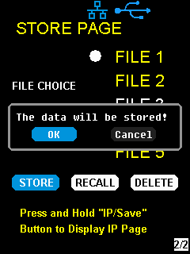
- Recall
Operation steps:
- Pres IP/Save button for 1 second or longer to enter to the Store Page screen.
- Press the left and right arrow buttons to move the cursor to "FILE CHOICE".
- Turn the rotary knob or press the Fine button briefly to select the instrument status file (FILE 1 ~ FILE 5).
- Press the arrow buttons to move the cursor to "OPER CHOICE"
- Turn the multi-function knob to select "RECALL" and press the knob or press the Fine button for 1 second or longer to select "OK" to recall the saved file.

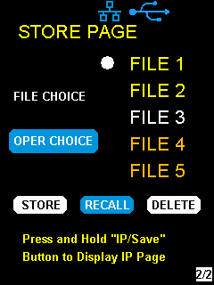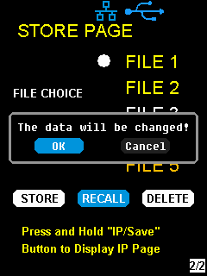

- Delete
- Press IP/Save for 1 second or longer to enter the Store Page interface;
- Press the left and right arrow buttons to move the cursor to "FILE CHOICE".
- Turn the rotary knob or press the Fine button briefly to select the instrument status file (FILE 1 ~ FILE 5).
- Press the arrow button to move the cursor to "OPER CHOICE"
- Turn the multi-function knob to select "DELETE" and press the knob or press the Fine button for 1 second or longer to select "OK" to read the saved file.

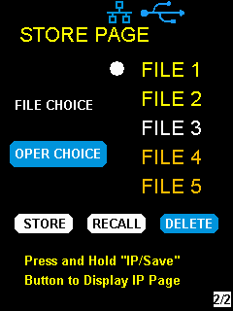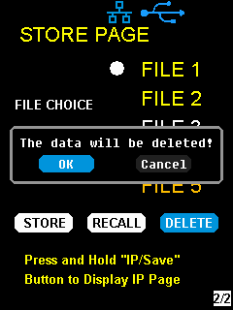

Timer
The SPD1000X provides a timer function. The timer can save five sets of settings, each set independent of the others. The user can set arbitrary parameters within the voltage, current, and dwell time values. The timer supports continuous output, with the longest time-out time of up to 10000 s.

- Set the timer parameter
Method 1:
- Press Timer/Wave to enter the Timer Setup interface, and the indicator will illuminate.
- Pressing the arrow keys, move the cursor to select the desired parameter (voltage/current/time).
- Rotate the multi-function knob or press the left and right buttons for 1 second or longer period to set the corresponding value. The Fine button can be used to move between the digits in any highlighted field.
- Press Timer/Wave again to exit the Timer interface.

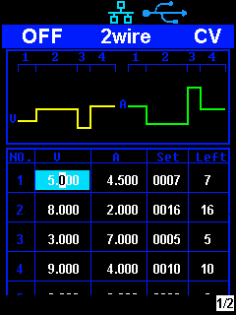

Start the Timer
- Using the arrow keys, move cursor to Timer at the bottom of the screen in the Timer interface screen.
- Rotate the multi-function knob to turn the Timer state to “ON”;
- Press the knob to start the Timer. Notice the countdown shown to the right of the Timer On/ Off indicator. It will begin to count down for each segment of the timer profile..
- Rotate the multi-function knob to turn the Timer state to “OFF”
- Or press the On/Off button for 1 second or longer to turn on/off the Timer.

Method 2:
- Press Timer/Wave button to enter the Timer interface.
- Press the knob, start the timer profile.
- Press the knob again, turn off the timer.
- Or press the On/Off button for 1 second or longer to turn on/off the Timer.

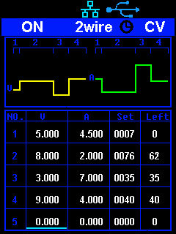

After starting the timer function, the timer will stop if you press the On/Off button to switch off the channel output. When the channel output is turned on again, the timer will continue counting from the last point in time it stopped. After the countdown steps have completed the timer will turn off automatically.

Waveform display
The SPD1000X displays the dynamic changing of the voltage and the current in the form of a trending graph.

Operation steps:

- Press the Timer/Wave key for 1 second or longer to open the channel waveform display function. Once activated, the key light will illuminate and the waveform display interface is activated.
- Press the On/Off key to turn on the output. Now you can observe the near-real-time changes of the channel output parameters (current/voltage).

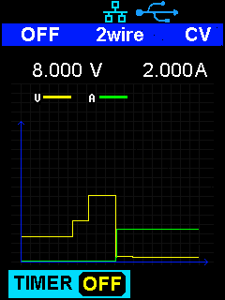

Note: The yellow line indicates the voltage output curve, the green line indicates the current output curve, and the ordinate axis indicates the output value.

Version information
Under any interface, press Ver/Lock to enter the version information display interface. Version information includes: the number of instrument power-up boot cycles, software version, hardware version, product model, product serial number.

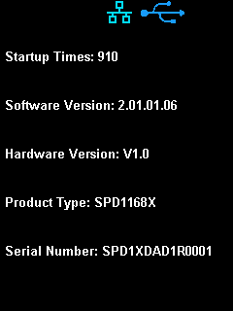

Lock key
The SPD1000X allows the user to lock the front panel keys to avoid the risk of inadvertently changing a setting. Under any interface on the front panel, press the Ver/Lock key for 1 second or longer to enable the key lock function. At this point, the other buttons on the front panel are disabled, except for the power button. After the lock function is enabled, a "lock" icon appears at the top of the screen. Press and hold the Ver/Lock key again to disable the key lock function. The "Lock" icon at the top of the screen disappears.

Upgrade firmware

Software Upgrades are performed using Easypower, a PC-based management software program (available on the Siglent website), this is used to update the power supplies firmware via USB Device or LAN. Upgrade as follows:

- Upgrade in normal Interface
- Open the EasyPower software after the USB interface has established its connection to the PC run the EasyPower software.
- Click Version and then choose Upgrade in the drop-down menu to enter the USB firmware upgrade dialogue.

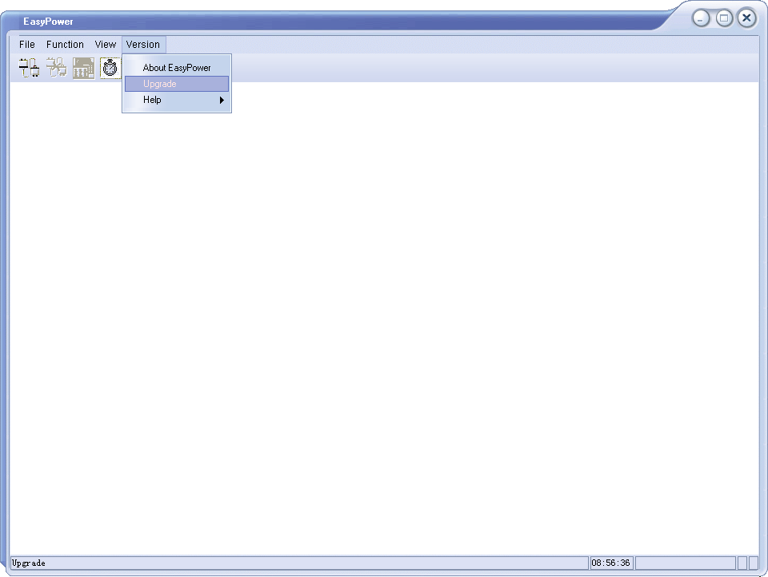

- Figure shows the firmware upgrade dialogue. Click file choosing icon , and then select the file to be upgraded which must have an ADS extension.
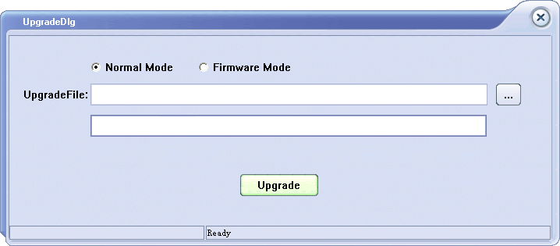

- As is shown in figure 4, click Upgrade button to begin the upgrade. The upgrade is finished when the progress bar completes and the instrument will automatically run the version after the upgrade.

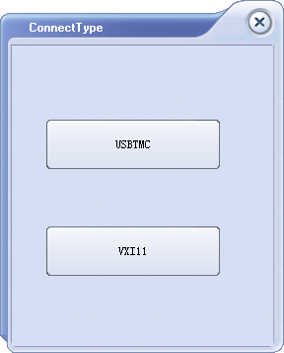

- Upgrade Via Guide Procedure
Upgrade via guide procedure also can be used if the method above does not work. Specific steps are as follows:
- Press the knob and simultaneously turn on the instrument. It will now enter the guide procedure mode.

- After entering the guide procedure mode, the upgrade method is the same as in the previous procedure.

Chapter 3 Remote control

3.1 Control method

Based on NI-VISA
Users can remotely control the instrument by using NI-VISA from NI (National Instruments Corporation). In regards to NI-VISA, there is a full version and a live version (Run-Time Engine version). The full version includes NI device drivers and a tool called NI MAX. NI MAX is a user interface that controls the device. The real-time version is much smaller than the full version and includes only NI device drivers.

For example, you can download and install the full version of NI-VISA 5.4 at http://www.ni.com/download/ni-visa-5.4/4230/en/.

Next use the USB cable to connect the SPD1000X (via the rear panel's USB Device connector) to the computer or use a network cable to connect the SPD1000X (through the back-panel’s LAN connector) to the computer's LAN.
Based on NI-VISA, the user can remotely control the SPD1000X in two ways; one through the PC software EasyPower and the other through custom programming with SCPI commands. For more information, see Programming Examples.

Using Socket
Users can also use Socket through the network port and SPD1000X for TCP/IP protocol-based communications. Socket communication is a basic communication technology in computer networks. It allows applications to communicate through network hardware and the standard network protocol built into the operating system. This method requires two-way communication between the instrument and the computer network through an IP address and a fixed port number. SPD1000X Socket communication port is 5025.
Using a network cable after connecting the SPD1000X (through the rear panel LAN connector) to the local area network where the computer is located, you can customize the programming with SCPI commands to remotely control the SPD1000X. For more information, see Programming Examples.

3.2 Grammar conventions
The SCPI command is a tree hierarchy that includes multiple subsystems, each consisting of a root key and one or more level keys. Command keywords are separated by a colon ":". The keywords are followed by optional parameter settings. Commands and parameters are separated by a space, and the parameters are separated by commas ",", add a question mark "?", after the command line to inquire about this function.
Most SCPI commands are a mixture of uppercase and lowercase letters. Capital letters indicate abbreviations of shortened commands. For better program readability, use the long commands convention. For example,
[CH1:]VOLTage <voltage>
VOLT or VOLTage, uppercase and lowercase letters in any combination will work. Therefore, VolTaGe, volt and Volt are acceptable. Other formats such as VOL and VOLTAG will generate errors.
- Brackets ({}) contain parameter choices. Brackets are not sent with the command string.
- Vertical line (|) separates parameter selections.
- Angle brackets (<>) indicates that you must specify a value for the parameter inside the brackets. For example, for the <voltage> parameter in angle brackets for the above command, you must specify a value for this parameter (for example, "CH1: VOLT 10"). Angle brackets do not send angle brackets along with the command string.
- Optional parameters are enclosed in square brackets ([]). If you do not specify a value for the optional parameter, the instrument uses the default value. For example, [CH1:] in the above command can be omitted (for example, "VOLT 10"). At this time, the command will operate on the current channel. Brackets are not sent with the command string.

Command Summary

- *IDN?
- *SAV
- *RCL
- INSTrument {CH1|CH2}
- INSTrument ?
- MEASure:CURRent?
- MEAsure:VOLTage?
- MEASure:POWEr?
- [SOURce:]CURRent <current>
- [SOURce:]CURRent ?
- [SOURce:]VOLTage <volt>
- [SOURce:] VOLTage?
- OUTPut
- OUTPut:TRACk
- OUTPut:WAVE
- TIMEr:SET
- TIMEr:SET?
- TIMEr
- SYSTem:ERRor?
- SYSTem:VERSion?
- SYSTem: STATus?

Command description
- *IDN?

Command format | *IDN?
Description | Query the manufacturer, product type, series NO. ,  software version and hardware version.
Return Info | Manufacturer, product type, series NO., software version.
Example | Siglent, SPD1168X, SPD1XDAD1R0001, 2.01.01.06,V1.0
- *SAV
Command format | *SAV <name>
Description | Save current state in nonvolatile memory with the specified name.
Example | *SAV 1
- *RCL
Command format | *RCL <name>
Description | Recall state that had been saved from nonvolatile memory.
Example | *RCL 1
- INSTrument
Command format | INSTrument <CH1>
Description | Select the channel that will be operated.
Example | INSTrument CH1

Command format | INSTrument?
Description | Query the current operating channel
Example | INSTrument?
Return Info | CH1

- MEASure
Command format | MEASure: CURRent? < CH1|CH2>
Description | Query current value for specified channel, if there is no specified channel, query the current channel.
Example | MEASure: CURRent? CH1
Return Info | 3.000

Command format | MEASure: VOLTage? < CH1>
Description | Query voltage value for specified channel, if there is no specified channel, query the current channel.
Example | MEASure: VOLTage? CH1
Return Info | 16.000

Command format | MEASure: POWEr? < CH>
Description | Query power value for specified channel, if there is no specified channel, query the current channel.
Example | MEASure: POWEr? CH1
Return Info | 90.000

- CURRent

Command format | <SOURce:>CURRent <value>  <SOURce>:={CH1}
Description | Set current value of the selected channel
Example | CH1:CURRent 0.5

Command format | <SOURce>: CURRent?  <SOURce>:={CH1}
Description | Query the current value of the selected channel.
Example | CH1: CURRent?
Return Info | 0.500
- VOLTage

Command format | <SOURce>: VOLTage <value>  <SOURce>:={CH1}
Description | Set voltage value of the selected channel
Example | CH1: VOLTage 15

Command format | <SOURce>:CURRent?  <SOURce>:={CH1}
Description | Query the voltage value of the selected channel.
Example | CH1: VOLTage?
Return Info | 15.000
- MODE

Command | MODE:SET {2W|4W}
Description | To set the work operation of 2W or 4W
Example | MODE:SET 4W

- OUTPut

Command format | OUTPut <SOURce>, <state>  <SOURce>:={CH1}; <state>:={ON|OFF}
Description | Turn on/off the channel.
Example | OUTPut CH1, ON

- TIMEr
Command format | TIMEr: SET <SOURce>, <secnum>, <volt>, <curr>, <time>  <SOURce>:={CH1}; < secnum >;=1 to 5;
Description | Set timing parameters of specified channel
Example | TIMEr: SET CH1, 2, 3, 0.5, 2

Command format | TIMEr: SET? <SOURce>, <secnum>  <SOURce>:={CH1}; < secnum >;=1 to 5;
Description | Query the voltage/current/time parameters of specified group of specified channel.
Example | TIMEr: SET? CH1, 2
Return Info | 3, 0.5, 2

Command format | TIMEr <SOURce>, <state>  <SOURce>:={CH1}; < state >;={ON | OFF};
Description | Turn on/off Timer function of specified channel
Instruction | The command works effectively only when <secnum> starts from 1.
Example | TIMEr CH1, ON

- SYSTem

Command format | SYSTem: ERRor?
Description | Query the error code and the information of the equipment.

Command format | SYSTem: VERSion?
Description | Query the software version of the equipment.
Example | SYSTem: VERSion?
Return Info | 2.01.01.06

Command format | SYSTem: STATus?
Description | Query the current working state of the equipment.
Instruction | The return info is Hexadecimal format, but the actual state is binary, so you must change the return info into a binary format. The state correspondence relationship is as follows.
Example | SYSTem: STATus?
Return info | 0x0224
Explanation: The returned information is hexadecimal, so the user needs to convert to binary format when confirming the status. See the following table:

Bit NO. | Corresponding state
0 | 0: CV mode 1: CC mode
4 | 0: Output OFF 1: Output ON
5 | 0: 2W mode 1: 4W mode
6 | 0: TIMER OFF 1: TIMER ON
8 | 0: digital display; 1: waveform display

- IPaddr

Command format | IPaddr <IP address>
Description | Used to assign a Static Internet Protocol (IP) address to the instrument
Example  Explanation | IPaddr 10.11.13.214  This command is invalid when the power is currently set to automatically obtain the network configuration (DHCP is ON)

Command format | IPaddr?
Description | Query the software the setting of IP address
Example | SYSTem: VERSion?
Return Info | 10.11.13.214

- MASKaddr

Command format | MASKaddr <NetMask>
Description | Used to assign a subnet mask to the instrument
Example  Explanation | MASKaddr 255.255.255.0  This command is invalid when the power is currently set to automatically obtain the network configuration (DHCP is ON)

Command format | MASKaddr?
Description | Query the software the setting of mask address
Example | SYSTem: VERSion?
Return Info | 255.255.255.0

- GATEaddr

Command format | GATEaddr <GateWay>
Description | Used to assign agateway to the instrument
Example  Explanation | GATEaddr 10.11.13.1  This command is invalid when the power is currently set to automatically obtain the network configuration (DHCP is ON)

Command format | MASKaddr?
Description | Query the software the setting of gateway address
Return Info | 10.11.13.1

- DHCP

Command format |  | DHCP{ON|OFF}
Description |  | Turn on or off the instrument's automatic network configuration feature.
Example |  | DHCP ON
Command format | DHCP?
Description | This is used to query whether the current automatic network configuration of the instrument is enabled
Return Info | ON

- *LOCK

Command format |  | *LOCK
Description |  | Turn on the key lock to disable local or remote settings.
Example |  | *LOCK
Command format | *UNLOCK
Description | Turn off the key lock to validate the setting
Example | *UNLOCK

Programming examples
This section lists examples of programming with SCPI commands based on NI-VISA or Socket in Visual C ++, Visual Basic, MATLAB, Python, and more.

NI-VISA-based programming examples
- First confirm that your computer has installed the NI VISA library (NI website can be downloaded from http://www.ni.com). The default installation path in this article is C: \Program Files\IVI Foundation\VISA.
- This article mainly uses the power of the USB interface and PC communications, some examples involve the use of LAN interface. Please use the USB cable to connect the USB Device port on the rear panel of the power supply to the USB port on the PC. You can also use the LAN interface to communicate with the PC.
- After the power is correctly connected to the PC for the first time, power on the instrument. At this time, the Hardware Update Wizard dialog box will pop up. Follow the instructions of the wizard to install the "USB Test and Measurement Device".
At this point, programming preparation is completed. The following will detail the Visual C + +, Visual Basic and MATLAB development environment programming examples.

Visual C ++ programming examples

Environment: Win7 32bit system, Visual Studio
Example content: Using NI-VISA, access control devices via USBTMC and TCP/IP, send commands to read the return value.

Follow these steps to complete the example:
- Open Visual Studio and create a new vc ++ win32 project.
Setting up the project environment to use the ni-visa library, you have two options for using ni-visa, static mode and automatic mode:
- static mode:
Find the files on the NI-VISA installation path: visa.h, visatype.h, visa32.lib. Copy them to your project and add them to the project. In the project .cpp file, add the following two lines
#include "visa.h"
#pragma comment(lib,"visa32.lib")
- automatic mode
Set .h files include directory, ni-visa installation path. In our computer, we set the path to: C: \Program Files\IVI Foundation\VISA\WINNT\include. Set this path to the project - Properties ——C / C ++ —— General - Additional include path, as shown:

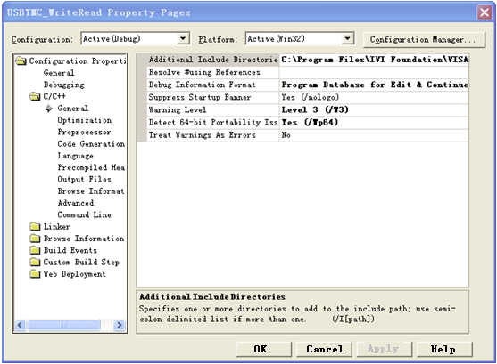

Set the library path to set the library file:
Set the library path: In your ni-visa installation path, in our computer, we set the path is: C: \Program Files\IVI Foundation\VISA\WINNT\LIB \MSC. Set this path to Project - Performance - Connector - General - additional library directory, as shown:
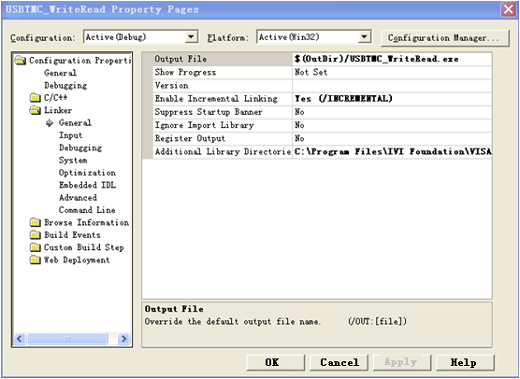

Set the library file：project---properties---Linker---Command Line---Additional Options:visa32.lib

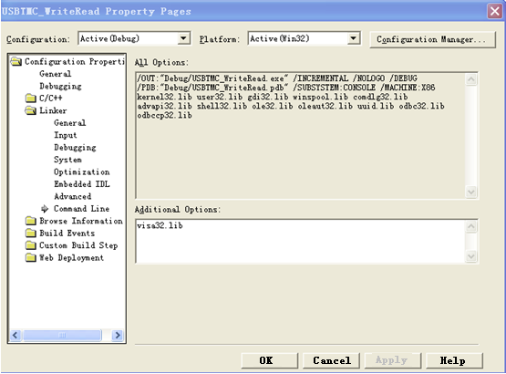

Including visa.h file: in XXX.cpp file:
#include <visa.h>
- Add code
- Based on USB interface code :
Write a Usbtmc_test function.
int Usbtmc_test ()
{
/* This code demonstrates using NI-VISA to send synchronous read and write commands to a USB Test & Measurement Class (USBTMC) instrument */
/* This example writes "* IDN? \n" string to all USBTMCs devices connected to the system and tries to read back the result using a read-write function */
/* The general flow of the code is to open the Explorer */
/* Open the VISA session to the instrument */
/* Use viPrintf to write the instrument flag */
/* Try to read a response with viScanf */
/* Close the VISA session */
/***********************************************************/
ViSession defaultRM;
ViSession instr;
ViUInt32 numInstrs;
ViFindList findList;
ViStatus status;
char instrResourceString[VI_FIND_BUFLEN];
unsigned char buffer[100];
char stringinput[512];
int i;
/* First, we have to call viOpenDefaultRM to get the manager's handle */
/* We will store this handle in defaultRM */
}

status=viOpenDefaultRM (&defaultRM);
if (status < VI_SUCCESS)
{
printf ("Could not open a session to the VISA Resource Manager!\n");
return status;
}
/** Look for all USB TMC VISA resources in our system */
/* Then the number of resources stored in the system numInstrs Lane*/
status = viFindRsrc (defaultRM, "USB?*INSTR", &findList, &numInstrs, instrResourceString);
if (status < VI_SUCCESS)
{
printf ("An error occurred while finding resources.\nHit enter to continue.");
fflush(stdin);
getchar();
viClose (defaultRM);
return status;
}

We will now open a VISA session for all USB TMC instruments. We have to use a handle from viOpenDefaultRM, and we have to use a string to indicate the instrument to open, which is called instrument descriptor. The format of the string can be found in the right-click parameter description in the function panel. After opening a session to the device, we get a handle to the instrument used later when using the VISA feature. The AccessMode and timeout parameters in this function are reserved for future functions. These two parameters are given the value VI_NULL. */
for (i=0; i<int(numInstrs); i++)
{
if (i > 0)
viFindNext (findList, instrResourceString);
status = viOpen (defaultRM, instrResourceString, VI_NULL, VI_NULL, &instr);
if (status < VI_SUCCESS)
{
printf ("Cannot open a session to the device %d.\n", i+1);
continue;
}
/** At this point, we now have a session open to the USB TMC instrument. Now, we will use the viPrintf function to send the string "* IDN? \ N" to the device, asking the device to recognize */

char * cmmand ="*IDN?\n";
status = viPrintf (instr, cmmand);
if (status < VI_SUCCESS)
{
printf ("Error writing to the device %d.\n", i+1);
status = viClose (instr);
continue;
}
/** Now we will try to read back the response of a device information query from the device. We will use the viScanf function to get the data. After the data is read out, the response is displayed */
status = viScanf(instr, "%t", buffer);
if (status < VI_SUCCESS)
printf ("Error reading a response from the device %d.\n", i+1);
else
printf ("\nDevice %d:%*s\n", i+1,retCount, buffer);
status = viClose (instr);
}
/** We will now close the session using the viClose instrument. This action frees up all system resources */
Return 0
}

- Based on the LAN port code
Write a TCP_IP_Test function.
int TCP_IP_Test (char * pIP)
{
char outputBuffer[VI_FIND_BUFLEN];
ViSession defaultRM, instr;
ViStatus status;
ViUInt32 count;
ViUInt16 portNo;
status = viOpenDefaultRM (&defaultRM);
if (status < VI_SUCCESS)
{
printf("Could not open a session to the VISA Resource Manager!\n");
}

char head[256] ="TCPIP0::";
char tail[] ="::INSTR";
char resource [256];
strcat(head,pIP);
strcat(head,tail);
status = viOpen (defaultRM, head, VI_LOAD_CONFIG, VI_NULL, &instr);
if (status < VI_SUCCESS)
{
printf ("An error occurred opening the session\n");
viClose(defaultRM);
}
status = viPrintf(instr, "*idn?\n");
status = viScanf(instr, "%t", outputBuffer);
if (status < VI_SUCCESS)
{
printf("viRead failed with error code: %x \n",status);
viClose(defaultRM);
}else
printf ("\ndata read from device: %*s\n", 0,outputBuffer);
status = viClose (instr);
status = viClose (defaultRM);
return 0;
}

Visual Basic programming examples

Environment: Windows 7 32-bit systerm , Microsoft Visual Basic 6.0
Example Content: Using NI-VISA, access control devices via USBTMC and TCP/IP, send commands to read the return value.
Follow the steps to complete the example:
- Open Visual Basic, create a standard application project (Standard EXE).
- Using the NI-VISA library to set up the project environment, click on the project's existing tab >> add module. Search for the include folder file under the NI-VISA installation path in visa32.bas and add the file.
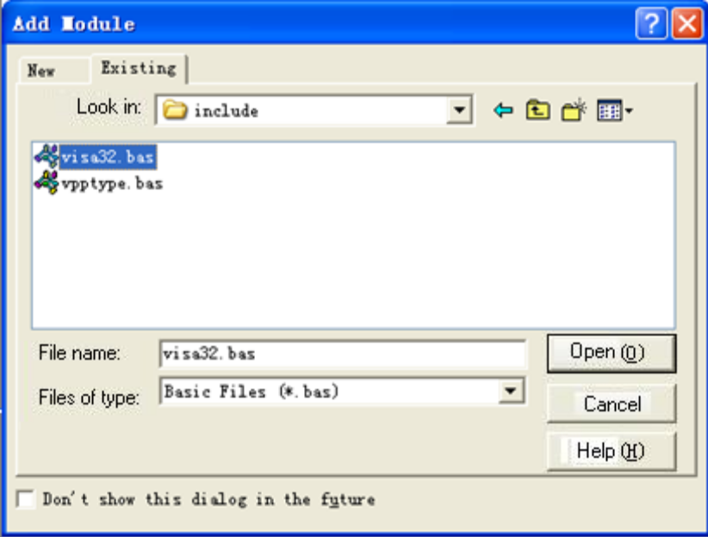
This allows VISA functions and VISA data types to be used in the program

- Add code
- Based on USB interface code:
Write Usbtmc_test function.
function USBTMC_test()

This code demonstrates using NI-VISA to send synchronous read and write commands to a USB Test & Measurement Class (USBTMC) instrument.
Create a VISA-USB object to connect to the USB instrument
vu = visa ('ni', 'USB0 :: 0xF4EC :: 0x1300 :: 0123456789 :: INSTR');

fopen(vu);

fprintf(vu,'*IDN?');
outputbuffer = fscanf(vu);
disp(outputbuffer);

fclose(vu);
delete(vu);
clear vu;

end

- Based on the LAN port code:
Write to the TCP_IP_Test function.
function TCP_IP_test( IPstr )
% This code demonstrates using NI-VISA to send synchronous read and write commands to a TCP / IP instrument.

% Create a VISA-TCPIP object to connect to an instrument with an IP address configured
vt = visa('ni',['TCPIP0::',IPstr,'::INSTR']);

% Open the created VISA object
fopen(vt);

% Send the string "* IDN?" To query device information
fprintf(vt,'*IDN?');

% Request data
outputbuffer = fscanf(vt);
disp(outputbuffer);

%Close the VISA object
fclose(vt);
delete(vt);
clear vt;

end

Socket-based programming examples
Python programming examples
Because the operating system itself supports Socket communication, this communication method is relatively concise. Note that the SPD1000X uses a fixed port number of 5025 for Socket communication, and the "\ n" (newline) must be added to the end of the SCPI command string.
Environment: Windows 7 32-bit system, Python v2.7.5
Example content: Access control devices via Socket, send commands to read the return value.
The following is the script content:
#!/usr/bin/env python
#-*- coding:utf-8 –*-
#---------------------------------------------------------------------------------------------------------
# Access the control device via Socket, send a command, read and print the return #value.
#----------------------------------------------------------------------------------------------------------
import socket # for sockets
import sys # for exit
import time # for sleep
#-----------------------------------------------------------------------------
remote_ip = "10.11.13.32"
port = 5025
count = 0

def SocketConnect():
try:
s = socket.socket(socket.AF_INET, socket.SOCK_STREAM)
except socket.error:
print ('Failed to create socket.')
sys.exit();
try:

s.connect((remote_ip , port))
except socket.error:
print ('failed to connect to ip ' + remote_ip)
return s

def SocketQuery(Sock, cmd):
try :
Sock.sendall(cmd)
time.sleep(1)
except socket.error:
print ('Send failed')
sys.exit()
reply = Sock.recv(4096)
return reply

def SocketClose(Sock):
Sock.close()
time.sleep(.300)

def main():
global remote_ip
global port
global count

s = SocketConnect()
for i in range(10):
qStr = SocketQuery(s, b'*IDN?\n')
print (str(count) + ":: " + str(qStr))
count = count + 1
SocketClose(s)
input('Press "Enter" to exit')

if __name__ == '__main__':
proc = main()

Chapter 4 Common troubleshooting
The most commonly encountered failures and their solutions are listed below. Please use these steps listed if an error occurs. If the problem persists, please contact SIGLENT .

- 1. The instrument will not power on.

- (1) Check whether the power is correctly connected.
- (2) Check whether the power switch at the front panel is on.
(3) Remove the power cord and check whether the voltage selector is at the proper setting, whether the specification of the fuse is correct and whether the fuse is intact. If the fuse needs to be changed, refer to “To Replace the Fuse”.
- (4) If the problem remains, please contact SIGLENT.

- 2. The constant voltage output is abnormal.

(1) Check whether the maximum output power of the scale currently selected fulfills the load requirement. If yes, go to the next step.
(2) Check whether the cable connecting the load and power supply is short-circuited and is making good contact.
- (3) Check whether the load is normal.
(4) Check whether the current setting value of this scale is proper; if it is too low, increase it accordingly
- (5) If the problem remains, please contact SIGLENT.

- 3. The constant current output is abnormal.

(1) Check whether the maximum output power of the scale currently selected fulfills the load requirement. If yes, go to the next step.
(2) Check whether the cable connecting the load and power supply is short-circuited and is making good contact.
- (3) Check whether the load is normal.
(4) Check whether the voltage setting value of this scale is proper; if it is too low, increase it properly.
- (5) If the problem persists, please contact SIGLENT.

Chapter 5 Service and Support

Maintenance summary
SIGLENT warrants that the products that it manufactures and sells will be free from defects in materials and workmanship for a period of three years from the date of shipment from an authorized SIGLENT distributor. If a product or CRT proves defective within the respective period, SIGLENT will provide repair or replacement as described in the complete warranty statement.
To arrange for service or obtain a copy of the complete warranty statement, please contact your nearest SIGLENT sales and service office. Except as provided in this summary or the applicable warranty Statement, SIGLENT makes no warranty of any kind, express or implied, including without limitation the implied warranties of merchantability and fitness for a particular purpose. In no Event shall SIGLENT be liable for indirect, special or Consequential damages

Contact SIGLENT

SIGLENT TECHNOLOGIES CO.，LTD

Address: 3/F, Building 4, Antongda Industrial Zone, 3rd Liuxian Road, 68 District, Bao’an District, Shenzhen, P.R. CHINA.

Tel: +86-755-36615186

E-mail:sales@siglent.com

http://www.siglent.com

America

SIGLENT Technologies America, Inc
6557 Cochran Rd Solon, Ohio 44139
Tel: 440-398-5800
Toll Free:877-515-5551
Fax: 440-399-1211
info@siglent.com
www.siglentamerica.com

Headquarters

SIGLENT TECHNOLOGIES CO., LTD.
Blog No.4 & No.5, Antongda Industrial Zone, 3rd Liuxian Road, Bao’an District, Shenzhen, 518101, China.
Tel:+ 86 755 3688 7876
Fax:+ 86 755 3359 1582
sales@siglent.com
www.siglent.com/ens

Europe

SIGLENT TECHNOLOGIES EUROPE GmbH
Liebigstrasse 2-20, Gebaeude 14, 22113 Hamburg Germany
Tel: +49(0)40-819-95946
Fax: +49(0)40-819-95947
info-eu@siglent.com
www.siglenteu.com

