Quick Start

SPD1000X Programmable Linear DC Power Supply

QS0501X-E02B

2018 SIGLENT TECHNOLOGIES CO.，LTD

Copyright and Declaration

Copyright
SIGLENT TECHNOLOGIES CO.，LTD. All Right Reserved.

Trademark Information
SIGLENT is a registered trademark of SIGLENT TECHNOLOGIES.

Declaration
- SIGLENT products are protected by patent law in and outside of the Peoples Republic of China
.
- SIGLENT reserved the right to modify or change the specifications and price of the product

- Information in this publication replace all previous corresponding material

- Any copying, extracting or translation of the content of this manual is not allowed without permission from SIGLENT.

General Safety Summary
Please review the following safety precautions carefully to avoid personal injury or damage to this product or any product connected to it. To prevent potential danger, please use the instrument as specified.

Use the proper power cord
Only the power cord designed for the instrument and authorized by the local country should be used.

Power supply
AC Input Voltages: 100/120/220/230 V ± 10%，50/60 Hz

Use the proper fuse
The fuse type: 100/120 V: T6.3A/250V
220/230 V : T3.15A/250V

Make sure to use the correct type of fuse before turning on the instrument.
Find the cause of the fuse failure before replacing the fuse and connecting the power cord.

Ground the instrument
The instrument is grounded through the protective earth conductor of the power cord. To avoid electric shock, the grounding conductor must be connected to the earth ground. Make sure that the instrument is properly grounded before any activating any inputs or outputs.

Examine all the terminal ratings
To avoid fire or electric shock, please examine all ratings and symbols on the instrument. Read this guide carefully to know more details about the ratings before connection.

Keep proper ventilation
Inadequate ventilation may cause an increase of temperature within the instrument, which can lead to further damage. Please keep proper ventilation and check the fan and air-vents regularly when using the instrument.

Operate condition
Location: indoor, no strong light, almost no interfering pollution
Relative humidity: < 80%
Altitude：< 2000 m
Temperature: 0℃ to 40℃

Electrostatic Prevention
Operate in an electrostatic discharge protective area environment to avoid damages induced by static discharges. Always ground both the internal and external conductors of the cable to release static before connecting.

Do not operate in an explosive atmosphere
To avoid personal injury or damage to instrument, please do not operate in an explosive atmosphere.

Keep surface of the product clean and dry
Avoid dust and moisture in the air as they can influence the performance of the instrument. Please keep surface of the product clean and dry.

General Safety Summary
Terms may appear on the product:

DANGER: Indicates direct injury or hazard that may happen.

WARNING: Indicates potential injury or hazard that may happen.

CAUTION: Indicates potential damage to the instrument or other property that may happen.

Symbols may appear on the product:

Hazardous
Warning
Power
Switch
Earth
Ground
Protective
Earth Terminal
Hazardous
Power

SPD1000X Brief Introduction
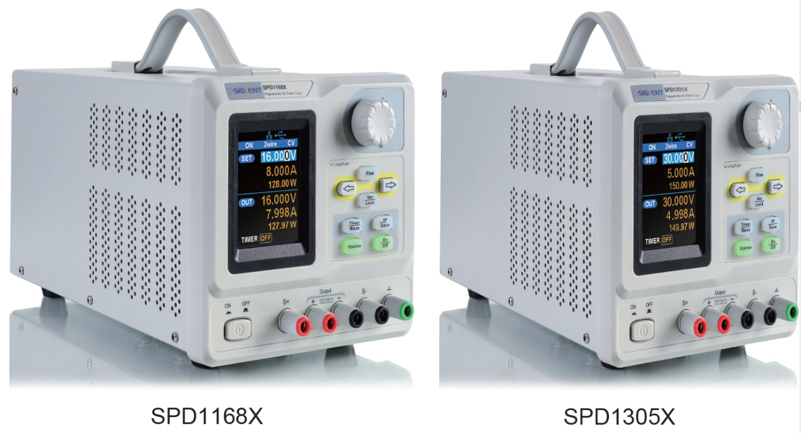
Siglent’s SPD1000X Programmable DC Power Supply has a 2.8 inch TFT-LCD screen, programmable output, and real time measurement graphing. The SPD1168X has a maximum output values of 16 V/8 A, while the SPD1305X has a maximum output values of 30 V/5 A. Both models have remote sense capability, output short circuit and overload protection.

Figure 1: Side view

Main features:

- Single high-precision programmable output:
SPD1168X：16 V/8 A, total power is 128 W
SPD1305X：30 V/5 A, total power is 150 W

- Compact, easy to use, powerful, ideal for bench power supply applications

- Stable, Reliable and Low Noise: ≤ 350 uVrms/3 mVpp

- Fast Transient Response Time: < 50μs

- Maximum resolution of 1mV/ 1mA with 5-bit voltage and 4-bit current display.

- Timer function sequences pre-set output values

- High resolution 2.8 inch TFT LCD(240*320 pixels)

- Two output modes: two-wire output and remote sense compensation function (maximum compensation up to 1V)

- Four varieties of input-line voltage values include 100V, 110V, 220V and 230V to satisfy user requirements

- Intelligent temperature-controlled fan, effectively reduces noise

- Clear graphical interface, with waveform display

- 5 internal system parameters save / recall, support for data storage space expansion

- Uses EasyPower PC software, real-time control via USB, LAN, support SCPI command set and LabView driver package to meet the remote control and communication requirements

Content
Quick Start I
Copyright and Declaration I
General Safety Summary II
General Safety Summary IV
SPD1000X Brief Introduction V
Ge Inspection 1
The Front Panel 2
The Rear Panel 5
Connect power 7
User interface 9
Output Inspection 11
Fuse Replacement 12
Troubleshooting 13
Contact SIGLENT 14

General Inspection
Please inspect your new instrument follow the steps below.

- Inspect the shipping container

Keep the shipping container or cushioning material until the contents of the shipment have been completely checked and the instrument has passed both electrical and mechanical tests. The consigner or carrier is responsible for damages to the instrument resulting from shipment. SIGLENT will not provide free maintenance or replacement for shipping damages.

- Inspect the instrument

If there is damage, defects, or failures in electrical and mechanical tests of the product, please contact your nearest SIGLENT sales representative.

- Check the accessories

Please check the accessories according to the packing list. If the
accessories are incomplete or damaged, please contact your
SIGLENT sales representative.

The Front Panel

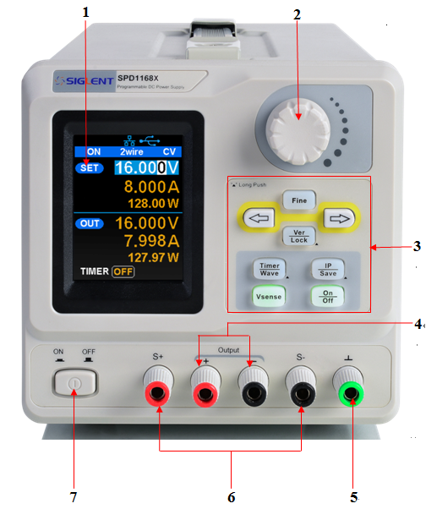

Figure 2: The front panel of the SPD1168X

- LCD
2.8 inch TFT display. It is used to display system parameter settings, system output state, menu options, prompt messages, etc.

- Knob
When setting parameters, rotate the knob to increase or decrease the value of the digit at the cursor.

- Function button and power key
When setting parameters, press the Fine button to move the cursor to select the position of digit to be modified.

The right and left direction buttons move the cursor to select the parameter to be modified.

Press the button briefly to enter the system message interface. Press the button for 1 second or longer to activate the lock function.

Press the button briefly to enter the timer interface. Press the left button to move the cursor from left to right，press the right button to move the cursor in the opposite direction. In the timer interface or main interface，press the On/Off button briefly to turn on/off the timer.
Press the button for 1 second or longer to enter the waveform display mode.

Press the button briefly to configure the network connection information. Then press the left button to move the cursor from right to left，press the right button to move the cursor from left to right. Choose the DHCP window，press the On/Off button for a short period to turn On/Off the DHCP function..
Press the button for a longer period to enter the storage function system. Press the Fine button for a short period to choose the subproject，press the Fine button for a longer period to determine the choice.

Press the button to enable/disable the remote sense function.

Press the button to enable/disable the channel output.

- Output Terminal
Physical output connections to the external circuit.

- Ground Terminal
This terminal is connected to the instrument chassis and ground wire and is in grounded state.

- Sense terminal
Used to sense the actual voltage at the load. This allows the source to compensate the voltage drop caused by the leads between the power supply and the load and increases the accuracy of the voltage delivered to the load.

- Power key
Turn on or off the instrument.

The Rear Panel

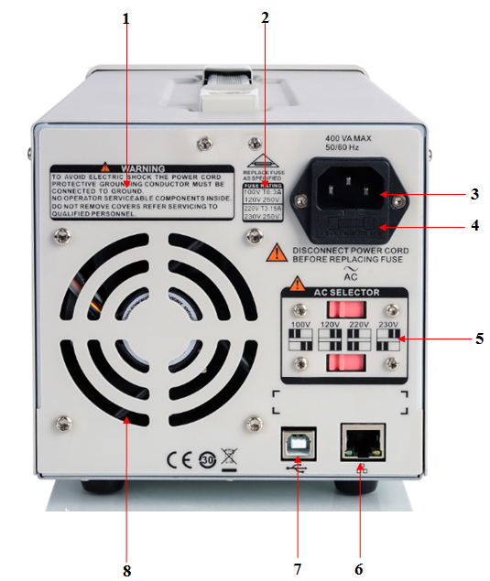

Figure 3: The rear panel of the SPD1000X

- Warning message
To note to ground the instrument and non-professional personnel should not disassemble the instrument and so on.

- AC input voltage description
The frequency、voltage and the specified fuse have to match with AC input .

- AC power socket
The socket of AC input power.

- Fuse
The needed specified fuse relate to the input voltage(Please refer to the “AC input voltage description“)

- AC line power selection switch
AC Input Voltages: 100/120/220/230 V

- LAN interface
Connect the local network by RJ45 interface.

- USB device
Connect the instrument (as “slave” device) to external USB device(such as, USB storage device) computer.

- Fan

Connect power
The power supply supports a variety of AC line power input values. For each line voltage, the rear panel voltage selector settings are different, as shown in table 1 below.

Table 1: AC input line power specifications
AC power input | Voltage selector configure
100 VAC ± 10%，50 ~ 60 Hz
120 VAC ± 10%， 50 ~ 60 Hz
220 VAC ± 10%， 50 ~ 60 Hz
230 VAC ± 10%， 50 ~ 60 Hz | 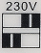

Please connect the power carefully follow the steps below:

- Check the input power
Make certain that the AC line power to be connect to the instrument meets the requirements in Table 1.

- Check the voltage selector at the rear panel
Make certain that the voltage selector setting at the rear panel of the instrument matches the actual input voltage.

- Check the fuse
When the instrument leaves factory, the specified fuse is installed. Please check whether the fuse matches the actual input voltage according to the "Input Power Requirements" at the rear panel of the instrument.

- Connect the power
Connect the instrument to AC power supply using the power cord provided in the accessories. Then press the button to turn on the power.

WARNING
Before switching the input power supply voltage, please disconnect the power supply before setting the voltage selector To the appropriate gear.

WARNING
To avoid electric shock, make sure that the instrument is correctly grounded.

User interface
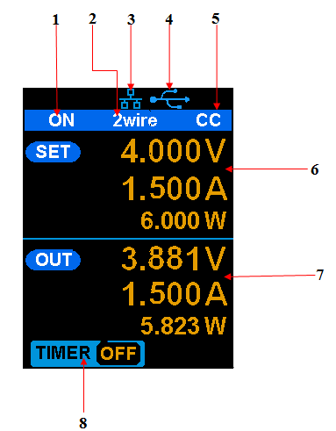
Figure 4: The user interface

- Channel output state

- Remote sense mode

- LAN connection icon

- USB connection icon

- Output mode

- Output programmed values

- Measured output values

- Timer state

Output Inspection

- Check the output voltage

- Turn on the power and make sure the channel current setting is not zero when the instrument has no-load.
- Press on/off button, the supply should be working in constant voltage (CV) mode. You can check the voltage range of SPD1168X by adjusting the voltage setpoint from the minimum (0 V) to the maximum value (16 V) and the voltage range of SPD1305X by adjusting the voltage setpoint from the minimum (0 V) to the maximum value (30 V).

- Check the output current

- Turn on the power and make sure the voltage setting is not zero.
- Connect the output terminals (short) with an insulated wire that can handle 10 A or more (18 AWG single core, for example).
- Activate the output by pressing the on/off button. The low impedance (shorted) output will cause the instrument to enter current control (CC) mode. You can check the current range of the SPD1168X by adjusting the current setpoint from the minimum (0 A) to the maximum value (8 A) and the current range of the SPD1305X by adjusting the current setpoint from the minimum (0 A) to the maximum value (5 A).

Fuse Replacement
The specifications of the fuse are relative to the actual input line voltage, shown in the table below. You also can refer to the rear panel “input power requirement”.
Input voltage | Fuse specification
100/120 VAC | T6.3A
220/230 VAC | T3.15A

To replace the fuse, please follow the steps below:
- Turn off the instrument and remove the power cord.
- Insert a small straight screwdriver into the slot at the power socket and gently pry out the fuse seat.
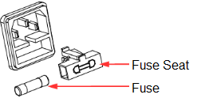
- Adjust the power voltage selector manually to select the correct voltage scale.
- Take out the fuse and replace it with the specified fuse (for the corresponding relations between the input voltage and fuse specification, refer to the “input power requirement” at the rear panel).
- Re-insert the fuse holder into the power socket (please pay attention to the direction).

WARNING
To avoid personal injuries, unplug the power supply before replacing the fuse. To avoid electric shock or fire, select the proper power supply specification and replace only with the proper fuse.

Troubleshooting
Here are some common failures and their solutions. If the problem persists after following the listed steps, please contact SIGLENT.

1. The instrument cannot start up.
- (1) Check whether the power is correctly connected.
(2) Check whether the power switch at the front panel is really on.

(3) Remove the power cord and check whether the voltage selector is at the proper scale, whether the specification of the fuse is correct and whether the fuse is intact. If the fuse needs to be changed, refer to “To Replace the Fuse”.
- (4) If the problem remains, please contact SIGLENT.

2. The constant voltage output is abnormal.
(1) Check whether the maximum output power of the scale currently selected fulfills the load requirement. If yes, go to the next step.
- (2) Check the cable connecting the load and power supply for
- short-circuits.
- (3) Check whether the load is normal.
(4) Check whether the current setting value of this scale is proper. If it is too low, increase it.
- (5) If the problem remains, please contact SIGLENT.

3. The constant current output is abnormal.
(1) Check whether the maximum output power of the scale currently selected fulfills the load requirement. If yes, go to the next step.
(2) Check whether the cable connecting the load and power supply is in good condition.
- (3) Check whether the load is normal.
(4) Check whether the voltage setting value of this scale is proper. If it is too low, increase it.
- (5) If the problem remains, please contact SIGLENT.

Contact SIGLENT
America

SIGLENT Technologies America, Inc
6557 Cochran Rd Solon, Ohio 44139
Tel: 440-398-5800
Toll Free:877-515-5551
Fax: 440-399-1211
info@siglent.com
www.siglentamerica.com

Headquarters

SIGLENT TECHNOLOGIES CO., LTD.
Blog No.4 & No.5, Antongda Industrial Zone, 3rd Liuxian Road, Bao’an District, Shenzhen, 518101, China.
Tel:+ 86 755 3688 7876
Fax:+ 86 755 3359 1582
sales@siglent.com
www.siglent.com/ens

Europe

SIGLENT TECHNOLOGIES EUROPE GmbH
Liebigstrasse 2-20, Gebaeude 14, 22113 Hamburg Germany
Tel: +49(0)40-819-95946
Fax: +49(0)40-819-95947
info-eu@siglent.com
www.siglenteu.com

